**Embedded Hardware and Operating Systems**

**Week 3 Assignment Report**

Ömer Emre Ekici

**BlinkC.nc**

The BlinkC module is implemented in this file. This module uses 3 timer interfaces, 1 led interface and 1 booting interface. When the module is initiated, timers are set to begin counting down periodically. There are also seperate event functions to do specific tasks for each time a timer fires. I defined the interface for the 3rd timer in the definition. I also added timer3 start to the boot function and added an event function for timer3 that prints a line to the debugger.

**BlinkAppC.nc**

This file defines the blink application. In the implementation, 3 timers are created and connected to the interfaces of BlinkC module. MainC and LedsC modules are connected to the BlinkC module as well. I created another timer module as Timer3 and wired it to the BlinkC module.

**runblink.py**

In this file, the Tossim simulator object is created, BlinkC module output is connected to the terminal, the the BlinkApp module is created and booted. I increased the range of the for loop from 100 to 2000 to run the simulation for longer.

**Original application output**

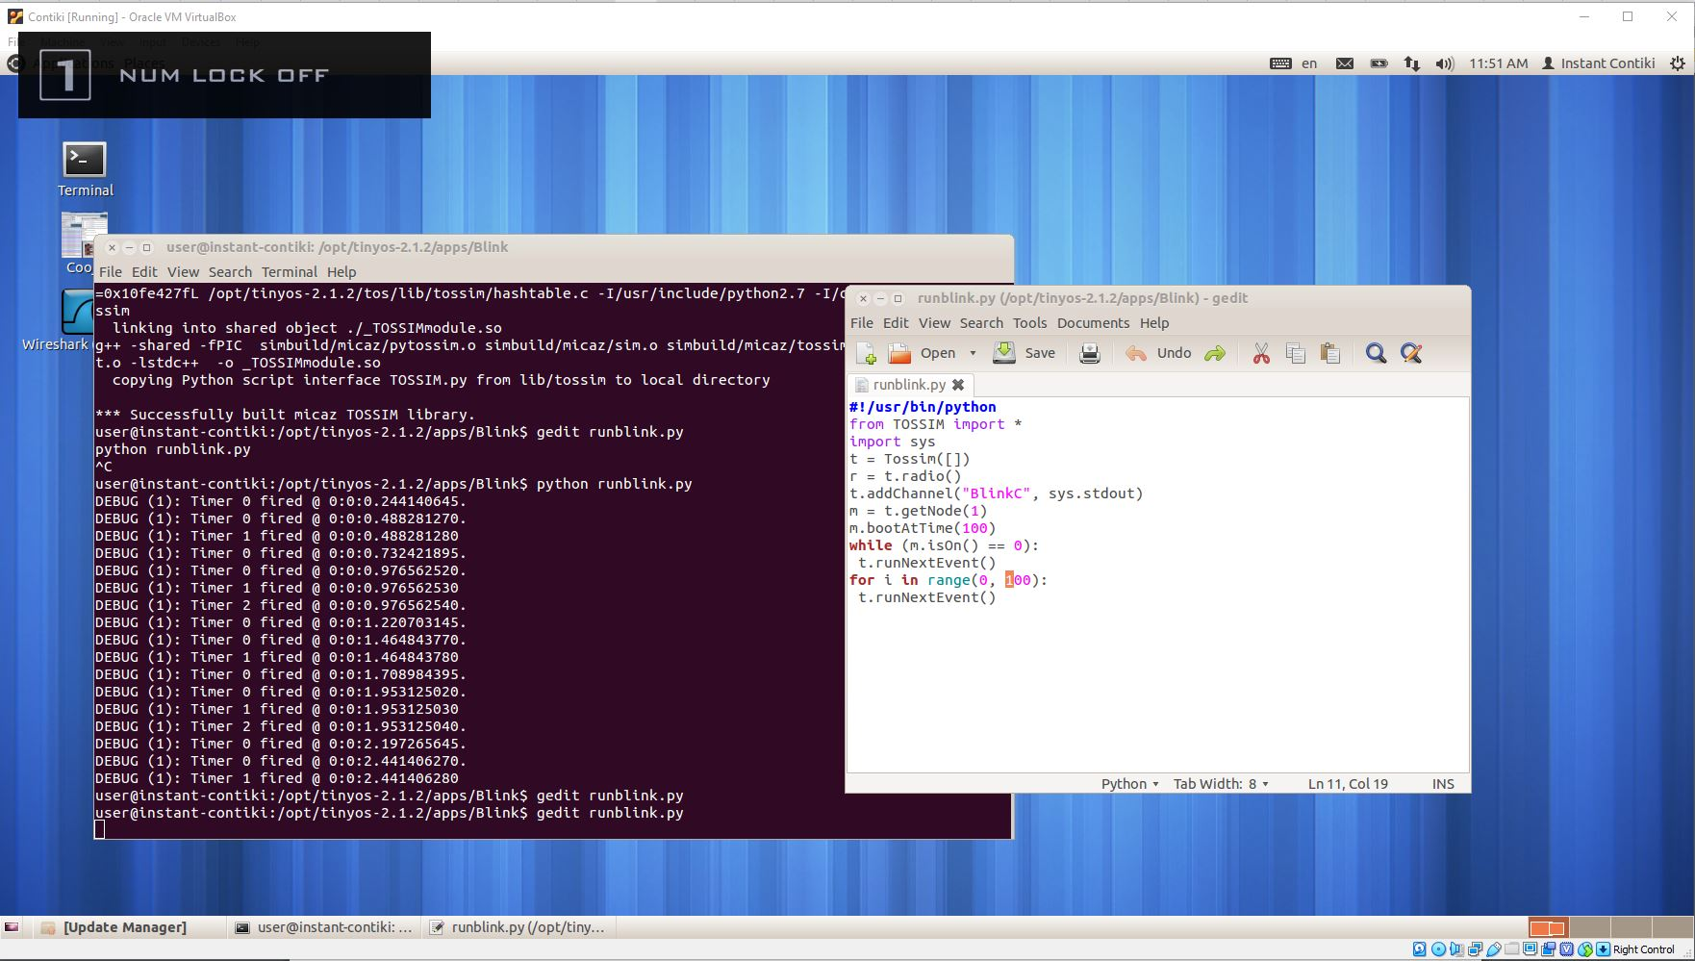

**Modified application output**

